**Project Management:**

**Exploring Web Development with Python: A Comprehensive Study with Applications (Blog) Built in Flask and Django**

Julia Gongala

B00402569

School of Computing, Engineering

and Physical Sciences

BSc (Honours) Web and Mobile Development

University of the West of Scotland

Supervisor: Tony Gurney

Moderator: Pablo Salva Garcia

Table of Contents

Abstract 2

Monday.com 3

Github 6

Formal Meetings 8

Table of Figures

Figure 1Monday.com Gantt chart 2

Figure 2 Exported Gantt chart 2

Figure 3 Exported timeline from monday.com - part 1 3

Figure 4 Exported timeline from monday.com - part 2 3

Figure 5Monday.com dashboard 4

Figure 6 GitHub repository 6

Figure 7Dissertation back up on GitHub 6

## Abstract

Project management stands as a pivotal component in the successful execution of any project, with numerous tools readily available to aid users in their endeavors. This report delves into the utilization of various tools employed in the management of the " Exploring Web Development with Python: A Comprehensive Study with Applications (Blog) Built in Flask and Django" project. From repositories hosted on platforms like GitHub for monitoring progress.

## Monday.com

# After receiving feedback about my Gantt chart during the interim report, I recognized the need to enhance my project management tracking. To address this, I turned to Monday.com, a powerful project management tool that offers a range of features to streamline workflows and improve collaboration.

# Utilizing Monday.com, I generated both a Gantt chart and a tracking board tailored to my project's requirements. The Gantt chart provides a visual representation of project timelines and dependencies, while the tracking board allows for detailed task management and progress monitoring.

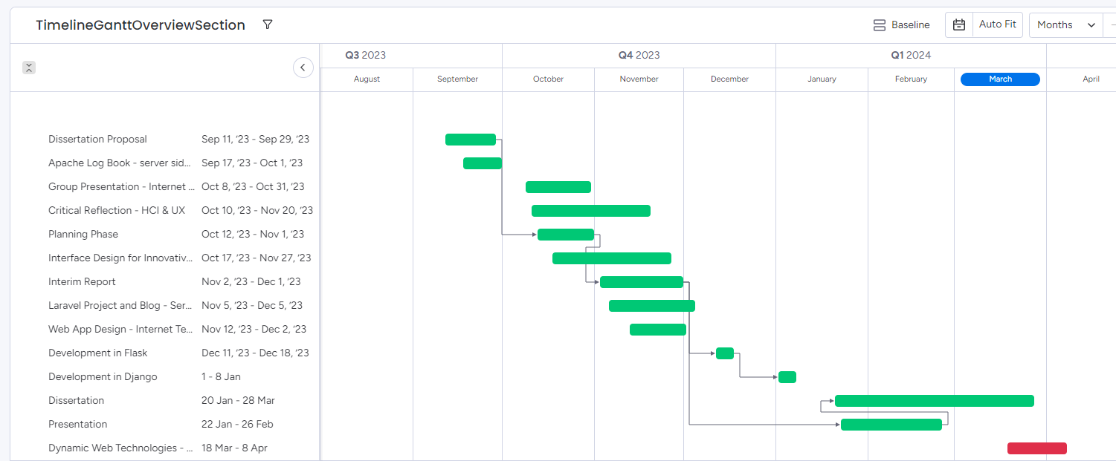

Figure 1Monday.com Gantt chart

Figure 2 Exported Gantt chart

# One of the key features I found useful is the ability to assign tasks to team members and track their progress in real-time. This feature not only helps in delegating responsibilities but also ensures accountability throughout the project lifecycle.

Figure 3 Exported timeline from monday.com - part 1

Figure 4 Exported timeline from monday.com - part 2

Figure 5Monday.com dashboard

Additionally, Monday.com offers integration with various third-party applications, allowing seamless connectivity with other tools I use in my project workflow. This integration simplifies data exchange and enhances overall efficiency.

# Furthermore, Monday.com provides insightful analytics and reporting features, allowing me to gain valuable insights into project performance and identify areas for improvement. By leveraging these analytics, I can make informed decisions to optimize my project management approach.

# Overall, utilizing Monday.com has significantly improved my project management tracking capabilities. Its intuitive interface, comprehensive features, and seamless integrations have made it an invaluable tool in ensuring the success of my projects.

## Github

For my project, "Exploring Web Development with Python: A Comprehensive Study with Applications (Blog) Built in Flask and Django," I find GitHub to be an invaluable tool for project management. With GitHub's robust set of features, I can efficiently organize and track progress throughout the development process. One of the first steps I take is creating a project board within my repository. This board allows me to define columns like "To Do," "In Progress," and "Completed," providing a visual representation of tasks and enabling me to easily move issues or tasks between stages as they progress.

GitHub's issue tracker is another crucial aspect of project management for me. I use it to log bugs, suggest enhancements, and discuss new features with my team. Being able to assign issues to team members, label them for categorization, and track their status as they're resolved greatly enhances collaboration and keeps the project moving forward smoothly.

In terms of backup, GitHub automatically backs up all my code and project-related files every time I push changes to my repository. This means that every commit, branch, and tag is securely stored on GitHub's servers. In case of data loss on my local machine or accidental deletion, I can easily restore my project to its previous state by cloning the repository or checking out specific commits. Features like protected branches and repository archiving further ensure the long-term integrity of my project's codebase.

Using Git, I seamlessly upload all changes of my project to GitHub. As I develop my Flask and Django applications locally, Git helps me track changes to my codebase and synchronize them with my GitHub repository. I start by initializing a new Git repository in my project directory, staging the files I want to commit, and creating a new commit with a descriptive message summarizing my changes. Then, using the git push command, I upload my commits to GitHub, where they're immediately reflected in my repository's history. By following best practices such as committing frequently, writing informative commit messages, and using meaningful branch names, I ensure a clear and organized history of my project's evolution on GitHub.

Figure 6 GitHub repository

Figure 7Dissertation back up on GitHub

## Formal Meetings

Formal meetings with my supervisor have been instrumental in guiding and refining my work on the project "Exploring Web Development with Python: A Comprehensive Study with Applications (Blog) Built in Flask and Django." These meetings serve as invaluable opportunities to discuss progress, address any challenges encountered, and receive valuable feedback.

Regrettably, these meetings haven't occurred as frequently as I would have liked. As the project progresses, I've found myself eager for more regular interactions with my supervisor to ensure alignment with expectations, gather insights, and seek clarification on various aspects of the project. More frequent meetings would have provided me with additional opportunities to benefit from my supervisor's expertise and guidance, ultimately enhancing the quality and efficiency of the project's execution.

Despite the limited frequency of formal meetings, I've made efforts to maximize the value of each interaction by coming prepared with specific questions, updates on my progress, and proposals for potential solutions or improvements. Additionally, I've proactively sought feedback through alternative channels such as email communication or scheduling ad-hoc meetings when urgent matters arise.

**FORM A**

**COMPUTING HONOURS PROJECT (COMP10034)**

**PROGRESS AND FEEDBACK MEETING AGENDA**

*(To be completed* ***before*** *the scheduled meeting)*

**Student:** Julia Gongala  **Supervisor:** Tony Gurney

**Meeting Number:** 1  **Date/Time:** 18/09/2023 15:00

**PROGRESS**

Over the last month, the following tasks have been completed:

* I have worked on project title, thesis and research regarding best application to be created
* I have worked on research relating front end and back end technologies
* Raspberry Pi set up

The following tasks identified last month have not been completed or problems/issues have emerged that require attention:

* None

**AGENDA FOR FORMAL MEETING (Example)**

1. Discussion of progress so far – presenting idea.
2. Discussion regarding project specification form.
3. Discussion about major milestones – Gantt Chart creation
4. Discussion on tasks to be carried out.
5. Discussion of work to be undertaken towards formal submissions (e.g. Interim Report)

**FORM B**

**COMPUTING HONOURS PROJECT (COMP10034)**

**PROGRESS AND FEEDBACK MEETING MINUTES AND PLAN**

*(To be completed* ***after*** *the scheduled meeting)*

**Student:** Julia Gongala  **Supervisor:** Tony Gurney

**Meeting Number:** 1 **Date/Time:** 18/09/2023 15:00

**MINUTES**

The following tasks and issues were discussed and specific actions agreed:

1. Discussed current work and tasks
2. Discussion regarding project specification form and final project plan
3. Discussion about creating 2 basic blogs and 1 advanced with better framework
4. Discussion about next milestones and gantt chart.

**PLAN**

The following tasks and timelines have been agreed both for the next month and beyond:

For the next month:

* Finish and submit project specification form
* Begin research and literature review regarding front end and back end technologies
* Interim Report focus

**FORM A**

**COMPUTING HONOURS PROJECT (COMP10034)**

**PROGRESS AND FEEDBACK MEETING AGENDA**

*(To be completed* ***before*** *the scheduled meeting)*

**Student:** Julia Gongala  **Supervisor:** Tony Gurney

**Meeting Number:** 2  **Date/Time:** 27/11/2023 15:00

**PROGRESS**

Over the last month, the following tasks have been completed:

* Project specification form has been submitted and confirmed
* I have worked on advanced research relating front end and back end technologies
* Project set up for flask and Django blog
* Template for main page has been created
* Interim report ready for submission? – first feedback

The following tasks identified last month have not been completed or problems/issues have emerged that require attention:

* None

**AGENDA FOR FORMAL MEETING (Example)**

1. Summary of what I have done so far.
2. Discussion about Raspberry Pi as a host. Will it work?
3. Discussion about Interim Report. Any corrections to do?
4. Discussion about next Development Phase.

**FORM B**

**COMPUTING HONOURS PROJECT (COMP10034)**

**PROGRESS AND FEEDBACK MEETING MINUTES AND PLAN**

*(To be completed* ***after*** *the scheduled meeting)*

**Student:** Julia Gongala  **Supervisor:** Tony Gurney

**Meeting Number:** 2  **Date/Time:** 27/11/2023 15:00

**MINUTES**

The following tasks and issues were discussed and specific actions agreed:

1. Discussed current work and progress
2. Discussion regarding interim report, layout, and specifications, focusing on my narrative style and move towards a more objective style of third person writing.
3. Discussion about development phase
4. Discussion about Virtual Machine, might be better than Raspberry Pi

**PLAN**

The following tasks and timelines have been agreed both for the next month and beyond:

For the next month:

* Finish, correct and submit Interim Report
* Research about Oracle VM VirtualBox
* Developing 2 basics blogs
* Preparations for presentation

**FORM A**

**COMPUTING HONOURS PROJECT (COMP10034)**

**PROGRESS AND FEEDBACK MEETING AGENDA**

*(To be completed* ***before*** *the scheduled meeting)*

**Student:** Julia Gongala  **Supervisor:** Tony Gurney

**Meeting Number:** 3  **Date/Time:** 08 /02/2023 11:00

**PROGRESS**

Over the last few month, the following tasks have been completed:

* Feedback from interim report – need to look in my gantt chart – improved with Monday.com
* I have worked on advanced research relating python development
* Based blogs created and hosted
* Presentation created
* Dissertation plan created

The following tasks identified last month have not been completed or problems/issues have emerged that require attention:

* None

**AGENDA FOR FORMAL MEETING (Example)**

1. Discussion of progress so far – presenting blogs – seems to be too easy – is it good enough?
2. Discussion regarding presentation – am I allowed to have notes.
3. Discussion about major milestones – Gantt Chart updated
4. Advanced blog features

**FORM B**

**COMPUTING HONOURS PROJECT (COMP10034)**

**PROGRESS AND FEEDBACK MEETING MINUTES AND PLAN**

*(To be completed* ***after*** *the scheduled meeting)*

**Student:** Julia Gongala  **Supervisor:** Tony Gurney

**Meeting Number:** 3  **Date/Time:** 08 /02/2023 11:00

**MINUTES**

The following tasks and issues were discussed and specific actions agreed:

1. Discussed current work and progress
2. Discussion regarding presentation
3. Discussion about development phase – blogs presented
4. Discussion about Virtual Machine – at the end blogs are hosted on Heroku and source code GitHub
5. Dissertation progres

**PLAN**

The following tasks and timelines have been agreed both for the next month and beyond:

For the next few months:

* Finish, correct and submit Dissertation
* Host advanced blog
* Presentation in 2 weeks
* Send dissertation to Tony for feedback

After receiving feedback on March 20th, I prioritized diving deeper into the technical implementation aspects of the project "Exploring Web Development with Python: A Comprehensive Study with Applications (Blog) Built in Flask and Django." This feedback served as a valuable guidepost, directing my attention towards refining the technical aspects of the project to ensure its successful execution.